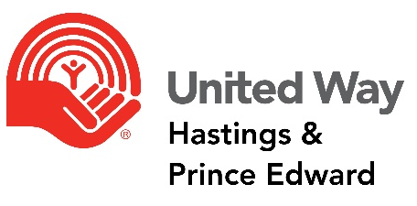

CITIZEN REVIEW PANEL APPLICATION

I am interested in serving on the Citizen Review Panel of United Way Hastings and Prince Edward. I understand that my application will be reviewed by the Community Impact team for consideration and presented to the Executive Director for appointment to the Citizen Review Panel. NOTE: All information supplied will be confidential to the Executive Director and Community Impact team.

Name:
Address:
Phone: | Home:
 | Work:
 | Cell:
Primary Email:
Occupation:

If you have previously participated in the United Way Citizens Review Panel, please tell us when?

☐2018 | ☐2019 | ☐2020 | ☐2021 | Other

Do you, or others in your family/household, have any current or past involvement with organizations that may be applying for funding through this year’s process?

If YES, please provide the following information:

 |  | Agency |  | Is it Current / Past Involvement? |  | Describe your involvement.
You | Family/Household Member
Tell us about any other volunteer experience you have:

Agency |  |  | Current / Past Involvement |  | Volunteer Role

Have you volunteered with United Way Hastings & Prince Edward or another United Way in the past?
If YES, please describe.

Please complete the following skills matrix and outline below the expertise you possess?

SKILLS | NONE | LIMITED | MODERATE | HIGH | FORMAL  TRAINING
Finance/Accounting
Governance/Policy
Outcome Measurement
Community Development
Understanding and knowledge of non-profit sector

Evaluation/grant reviewing
Working knowledge/proficiency with online
Software applications
Other

Other

Other

Other

What are your personal and/or professional strengths and characteristics that will make you an effective Citizen Review Panel Member?

Why are you interested in applying to become a Citizen Review Panel Member of United Way Hastings & Prince Edward?

____________________________________ ____________________________________________________
Signature Date

For further information or to submit an application please contact:
Alyssa Cooke, Community Impact Coordinator
United Way Hastings & Prince Edward
55 Harriett St. Belleville, ON K8P 1V6
Phone: 613-962-9531
acooke@unitedwayhpe.ca

